AWS WAF and Systems Manager

What is AWS WAF?
You can use AWS WAF, AWS Shield, and AWS Firewall Manager together to create a comprehensive security solution. AWS WAF is a web application firewall that you can use to monitor web requests that your end users send to your applications and to control access to your content. Shield Advanced provides protection against distributed denial of service (DDoS) attacks for AWS resources, at the network and transport layers (layer 3 and 4) and the application layer (layer 7). AWS Firewall Manager provides management of protections like AWS WAF and Shield Advanced across accounts and resources, even as new resources are added.
AWS WAF (Web Application Firewall) protects web applications from common web attacks like:
- SQL Injection (SQLi)
- Cross-Site Scripting (XSS)
- Bots
- HTTP Flood attacks

Why Use AWS WAF?
- Protect websites and APIs
- Block malicious traffic
- Allow trusted users
- Filter HTTP/HTTPS requests

Components
- Web ACL – Main firewall
- Rules – Allow/Block requests
- Rule Groups – Collection of rules
- Managed Rules – AWS-provided rules
- Custom Rules – User-created rules

Supported Services
- CloudFront
- Application Load Balancer (ALB)
- API Gateway
- AppSync
- Cognito

AWS WAF Hands-on

Hands-on 1: Create a Web ACL
- AWS Console → WAF & Shield
- Click Create web ACL
- Name : MyWebACL
- Region: US East (N. Virginia)
- Resource type: Regional resources
- Resource: Select your ALB
- Click Next
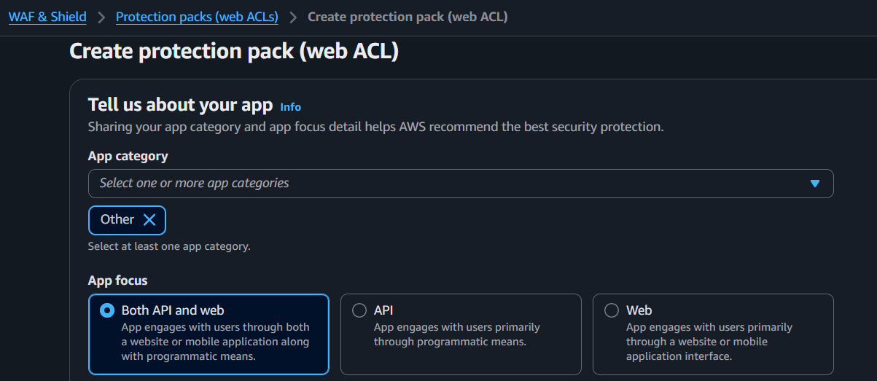
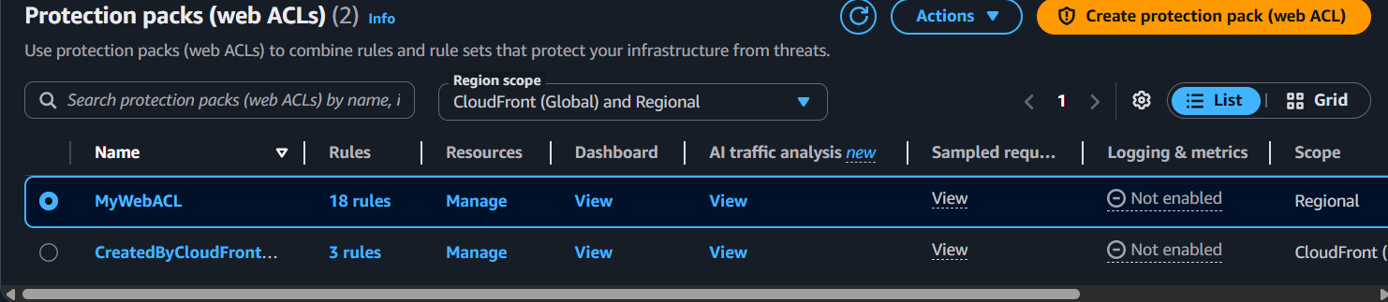

Hands-on 2: Add Managed Rule
- Click Add rules
- Select Add managed rule groups
- Choose: AWS Managed Rules
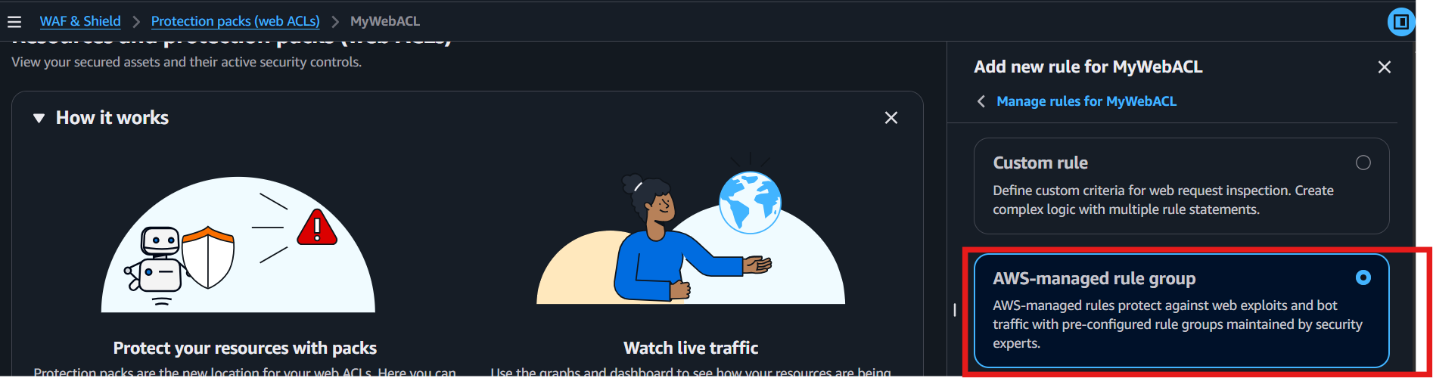
- Select: Core Rule Set
- Click Add rules
- Click Next

Hands-on 3: Review and Create
- Review the settings.
- Click Create web ACL.
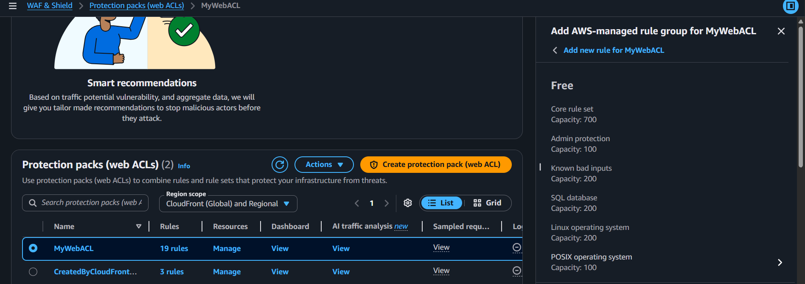

Hands-on 4: Verify
- Open your Web ACL.
- Go to Overview.
- Verify:
  - Web ACL created
  - ALB attached
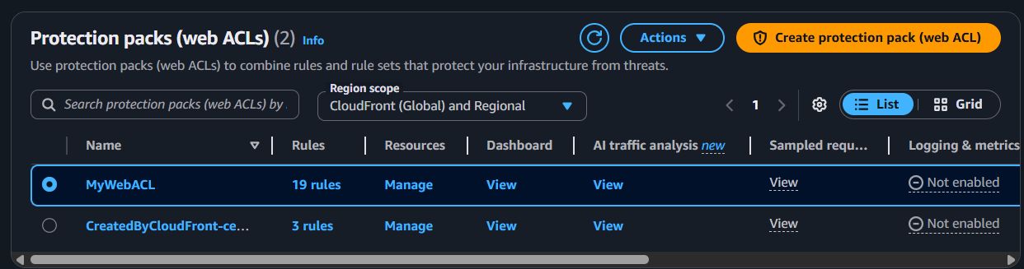
  - Rules are active
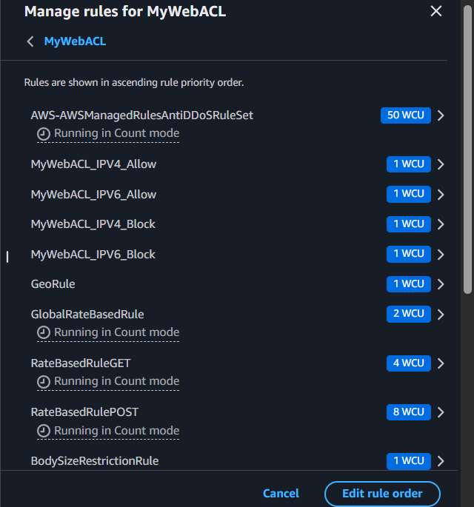

Hands-on 5: Test
- Open your website through the ALB.
- Verify the website loads normally.
- Send a test request (or monitor traffic).
- Check Requests and Metrics in the WAF console.

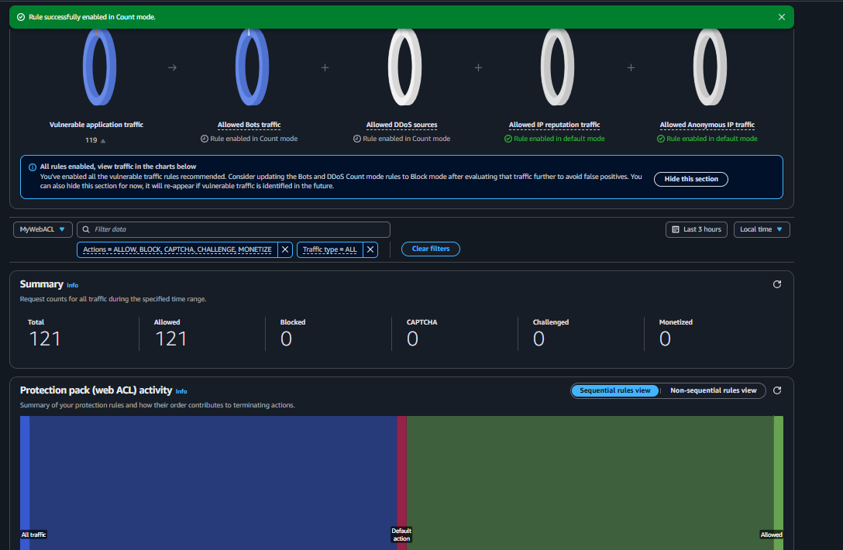

What is AWS Systems Manager?
AWS Systems Manager (SSM) is a service that helps you centrally manage, monitor, and operate your AWS resources (nodes) across AWS, on-premises, and multicloud environments from a single console. It enables secure remote management, automation, patching, command execution, and configuration management without needing to log in to each server individually.

Benefits
- Centralized management
- Run commands remotely
- Secure access without SSH
- Automate administrative tasks
- Patch management
- Store configuration and secrets (Parameter Store)

Main Features
- Session Manager – Securely connect to EC2 without SSH.
- Run Command – Run commands on one or more EC2 instances.
- Parameter Store – Store configuration values and secrets.
- Patch Manager – Apply OS patches.
- Automation – Automate operational tasks.

Step 1: Open AWS Systems Manager
- Sign in to the AWS Management Console.
- Search for Systems Manager.
- Open Systems Manager.
AWS Management Console
↓
Search: Systems Manager
↓
AWS Systems Manager

Step 2: Open Parameter Store
Systems Manager
↓
Application Management
↓
Parameter Store

Step 3: Create a Parameter
Click Create parameter and enter:
Field | Value
Name | /myapp/db-password
Tier | Standard
Type | SecureString
KMS Key | aws/ssm
Value | MyPassword@123
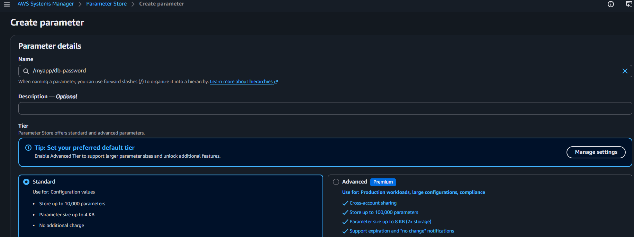
Click Create parameter.

Step 4: Verify the Parameter
- Open Parameter Store.
- Confirm that /myapp/db-password is listed.
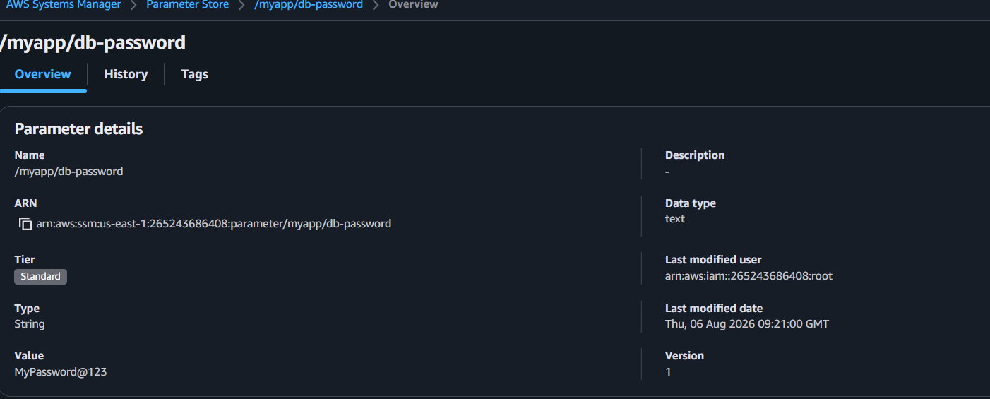

Step 5: Retrieve the Parameter
aws ssm get-parameter \
--name "/myapp/db-password" \
--with-decryption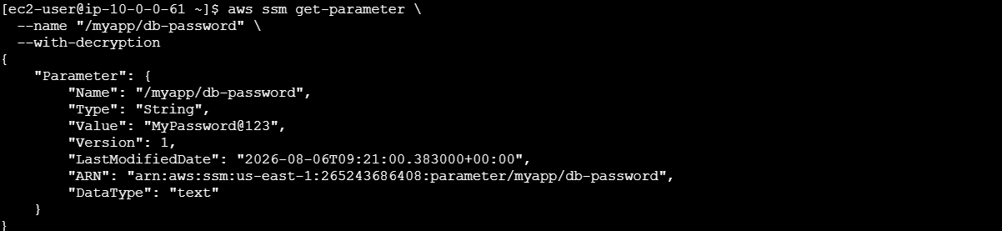

Step 6: Update the Parameter
aws ssm put-parameter \
--name "/myapp/db-password" \
--value "NewPassword@123" \
--type SecureString \
--overwrite 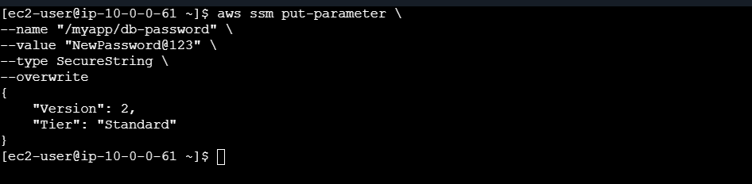

Step 7: Verify the Updated Value
aws ssm get-parameter \
--name "/myapp/db-password" \
--with-decryption 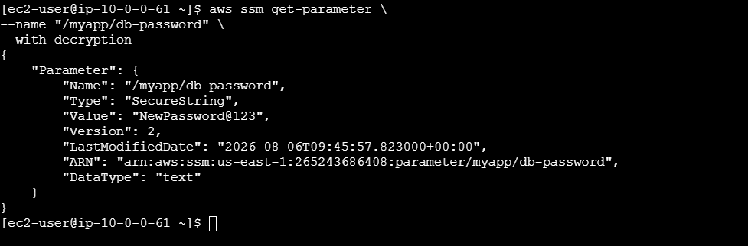

Step 8: Delete the Parameter
aws ssm delete-parameter \
--name "/myapp/db-password" 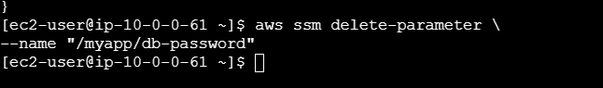

Step 9: Verify Deletion
- Refresh the Parameter Store page.
- Confirm the parameter is no longer listed.
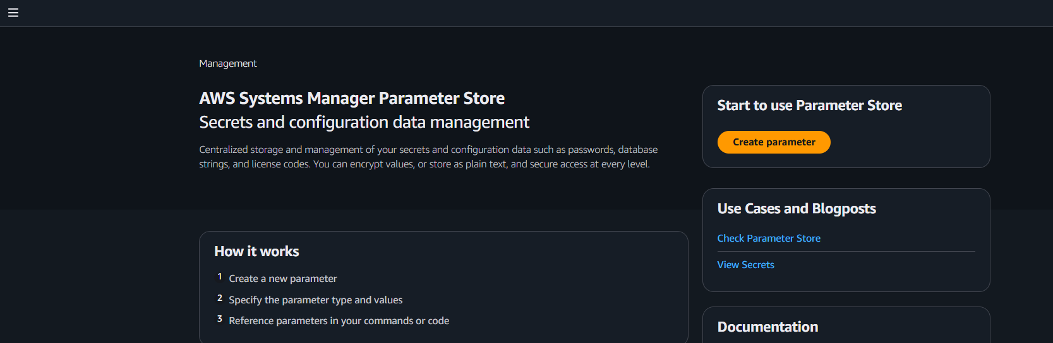

Lab Outcome
- ✅ Created a SecureString parameter.
- ✅ Retrieved it using the AWS CLI.
- ✅ Updated the parameter.
- ✅ Deleted the parameter successfully.

